For Internal Use Only: Date Request Received:

 | 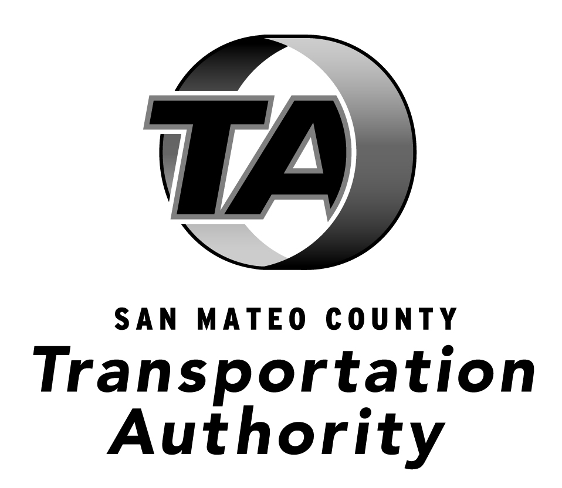
Requests may be submitted by any method listed below.
Mail:  Attention: District Secretary – PRA  San Mateo County Transit District  1250 San Carlos Avenue  San Carlos, CA 94070 |  | E-mail: PRA@samtrans.com  Fax: 650-508-6281
Public Records Request Form
First Name | Last Name |  | Date Requested
Street Address
City | State |  | Zip Code
E-Mail Address | Phone Number |  | Fax Number
Description of the Public Records Requested

